Приложение А
(обязательное)

Текст программы

Файл Form1.cs

using System;
using System.Collections.Generic;
using System.ComponentModel;
using System.Data;
using System.Data.OleDb;
using System.Drawing;
using System.Linq;
using System.Text;
using System.Threading.Tasks;
using System.Windows.Forms;

namespace test
{

public partial class Form1 : Form
{
private OleDbConnection myConnection;
public static string connectString = "Provider=Microsoft.Jet.OLEDB.4.0;Data Source=Library.mdb;";
public Form1()
{
InitializeComponent();
myConnection = new OleDbConnection(connectString);
// открываем соединение с БД
myConnection.Open();

}

private void button1_Click(object sender, EventArgs e)
{
Form2 f2 = new Form2();
f2.Owner = this;
//авторизация админа
if (textBox1.Text == "admin" && textBox2.Text == "83erisup")
{
this.Hide();
f2.Show();

}
else MessageBox.Show("Некорректные данные для входа");
}

private void button2_Click(object sender, EventArgs e)
{
this.Close();
myConnection.Close();
}

private void Form1_FormClosing(object sender, FormClosingEventArgs e)
{
myConnection.Close();
}

}
}
Файл Form2.cs

using System;
using System.Collections.Generic;
using System.ComponentModel;
using System.Data;
using System.Data.OleDb;
using System.Drawing;
using System.Linq;
using System.Text;
using System.Threading.Tasks;
using System.Windows.Forms;

namespace test
{
public partial class Form2 : Form
{
public static string connectString = "Provider=Microsoft.Jet.OLEDB.4.0;Data Source=Library.mdb;";
private OleDbConnection myConnection;
public Form2()
{
InitializeComponent();

dataGridView1.SelectionMode = DataGridViewSelectionMode.FullRowSelect;
dataGridView1.AllowUserToAddRows = false;
myConnection = new OleDbConnection(connectString);
// открываем соединение с БД
myConnection.Open();
}

private void Form2_FormClosing(object sender, FormClosingEventArgs e)
{
// закрываем соединение с БД
myConnection.Close();

}

private void выходToolStripMenuItem_Click(object sender, EventArgs e)
{
myConnection.Close();
this.Close();
}

private void button3_Click(object sender, EventArgs e)
{
//удаление книги
if (textBox1.Text != "")
{
//проверяем есть ли такое значение в таблице
int l = 0;
for (int i = 0; i < this.dataGridView1.RowCount; i++)
{
dataGridView1.Rows[i].DefaultCellStyle.BackColor = Color.White;
if (dataGridView1.Rows[i].Cells[0].Value.ToString().Contains(textBox1.Text))
{
dataGridView1.Rows[i].Cells[0].Style.BackColor = Color.Green;
l = 1;
break;
}
}
if (l == 1)
{
int kod = Convert.ToInt32(textBox1.Text);
string query = "DELETE FROM Knigi WHERE [Kod_knigi]="+kod;
OleDbCommand command = new OleDbCommand(query, myConnection);
command.ExecuteNonQuery();
MessageBox.Show("Данные о книге успешно удалены");
string query1 = "SELECT Knigi.Kod_knigi AS [Код книги], Knigi.Naimenovanie_knigi AS [Название книги], Knigi.Avtor AS [Автор], Knigi.Gog AS [Год издания], Janri.Nazvanie AS [Жанр], Chitateli.Familiya AS [Фамилия читателя], Chitateli.Imya AS [Имя читателя], Chitateli.Otchestvo AS [Отчество читателя] FROM Chitateli RIGHT JOIN (Janri RIGHT JOIN Knigi ON Janri.Kod_janra = Knigi.Kod_janra) ON Chitateli.Nomer_chit_bileta = Knigi.Nomer_chit_bileta";
OleDbDataAdapter adapter = new OleDbDataAdapter(query1, myConnection);
DataTable dm = new DataTable();
adapter.Fill(dm);
dataGridView1.DataSource = dm;
adapter.Update(dm);
//очищаем поля
textBox1.Text = "";
}
else MessageBox.Show("Такого значения в таблице нет!");
}
else MessageBox.Show("Введите код книги!");

}

private void button2_Click(object sender, EventArgs e)
{
if (textBox2.Text != "")
{
//проверяем есть ли такое значение в таблице
int l = 0;
for (int i = 0; i < this.dataGridView1.RowCount; i++)
{
dataGridView1.Rows[i].DefaultCellStyle.BackColor = Color.White;
if (dataGridView1.Rows[i].Cells[0].Value.ToString().Contains(textBox2.Text))
{
dataGridView1.Rows[i].Cells[0].Style.BackColor = Color.Green;
l = 1;
break;
}
}
if (l == 1)
{
if (textBox2.Text != "" || textBox3.Text != "")
{
//изменить данные о читателе
int kod = Convert.ToInt32(textBox2.Text);
string query = "UPDATE Knigi SET Naimenovanie_knigi='" + textBox3.Text + "' WHERE [Kod_knigi]="+kod;
string query1 = "SELECT Knigi.Kod_knigi AS [Код книги], Knigi.Naimenovanie_knigi AS [Название книги], Knigi.Avtor AS [Автор], Knigi.Gog AS [Год издания], Janri.Nazvanie AS [Жанр], Chitateli.Familiya AS [Фамилия читателя], Chitateli.Imya AS [Имя читателя], Chitateli.Otchestvo AS [Отчество читателя] FROM Chitateli RIGHT JOIN (Janri RIGHT JOIN Knigi ON Janri.Kod_janra = Knigi.Kod_janra) ON Chitateli.Nomer_chit_bileta = Knigi.Nomer_chit_bileta";

OleDbCommand command = new OleDbCommand(query, myConnection);
command.ExecuteNonQuery();
MessageBox.Show("Название книги успешно обновлено");
OleDbDataAdapter adapter = new OleDbDataAdapter(query1, myConnection);
DataTable dm = new DataTable();
adapter.Fill(dm);
dataGridView1.DataSource = dm;
adapter.Update(dm);
//очищаем поля
textBox2.Text = "";
textBox3.Text = "";
}
else MessageBox.Show("Не заполнены значения для изменения!");
}
else MessageBox.Show("Такого кода книги в таблице нет!");
}
else MessageBox.Show("Введите код книги!");

}

private void Form2_Load(object sender, EventArgs e)
{

string query1 = "SELECT Knigi.Kod_knigi AS [Код книги], Knigi.Naimenovanie_knigi AS [Название книги], Knigi.Avtor AS [Автор], Knigi.Gog AS [Год издания], Janri.Nazvanie AS [Жанр], Chitateli.Familiya AS [Фамилия читателя], Chitateli.Imya AS [Имя читателя], Chitateli.Otchestvo AS [Отчество читателя] FROM Chitateli RIGHT JOIN (Janri RIGHT JOIN Knigi ON Janri.Kod_janra = Knigi.Kod_janra) ON Chitateli.Nomer_chit_bileta = Knigi.Nomer_chit_bileta";
OleDbDataAdapter adapter = new OleDbDataAdapter(query1, myConnection);
DataTable dm = new DataTable();
adapter.Fill(dm);
dataGridView1.DataSource = dm;
adapter.Update(dm);

}

private void comboBox1_SelectedIndexChanged(object sender, EventArgs e)
{
if (comboBox1.SelectedItem != null)
label5.Text = comboBox1.SelectedValue.ToString();
else label5.Text = "0";
}

private void button4_Click(object sender, EventArgs e)
{
if (textBox4.Text == "" && textBox5.Text == "")
MessageBox.Show("Пожалуйста, заполните поля!");
else
{//добавление книги
string Name = textBox4.Text;
string Autor = textBox5.Text;
DateTime Date = Convert.ToDateTime(dateTimePicker1.Text);
string query = "INSERT INTO Knigi (Naimenovanie_knigi, Avtor, Gog, Kod_janra) VALUES ('" + Name + "','" + Autor + "','" + Date + "','" + Convert.ToInt32(label5.Text) + "')";
OleDbCommand command = new OleDbCommand(query, myConnection);
command.ExecuteNonQuery();
MessageBox.Show("Книга успешно добавлена");
string query1 = "SELECT Knigi.Kod_knigi AS [Код книги], Knigi.Naimenovanie_knigi AS [Название книги], Knigi.Avtor AS [Автор], Knigi.Gog AS [Год издания], Janri.Nazvanie AS [Жанр], Chitateli.Familiya AS [Фамилия читателя], Chitateli.Imya AS [Имя читателя], Chitateli.Otchestvo AS [Отчество читателя] FROM Chitateli RIGHT JOIN (Janri RIGHT JOIN Knigi ON Janri.Kod_janra = Knigi.Kod_janra) ON Chitateli.Nomer_chit_bileta = Knigi.Nomer_chit_bileta";
OleDbDataAdapter adapter = new OleDbDataAdapter(query1, myConnection);
DataTable dm = new DataTable();
adapter.Fill(dm);
dataGridView1.DataSource = dm;
adapter.Update(dm);
}
//очищаем поля
textBox4.Text = "";
textBox5.Text = "";

}

private void выданныеКнигиToolStripMenuItem_Click(object sender, EventArgs e)
{
Form4 f4 = new Form4();
f4.Owner = this;
f4.Show();
}

private void жанрыToolStripMenuItem_Click(object sender, EventArgs e)
{
Form5 f5 = new Form5();
f5.Owner = this;
f5.Show();
}

private void поискToolStripMenuItem_Click(object sender, EventArgs e)
{
Form3 f3 = new Form3();
f3.Owner = this;
f3.Show();
}

private void button6_Click(object sender, EventArgs e)
{
Form4 f4 = new Form4();
f4.Owner = this;
f4.Show();
}

private void справочникиToolStripMenuItem1_Click(object sender, EventArgs e)
{
Form5 f5 = new Form5();
f5.Owner = this;
f5.Show();
}

private void comboBox1_DropDown(object sender, EventArgs e)
{
string query2 = "SELECT Janri.Kod_janra, Janri.Nazvanie,Janri.Opisanie FROM Janri";
OleDbDataAdapter adapter = new OleDbDataAdapter(query2, myConnection);
DataTable dv = new DataTable();
adapter.Fill(dv);
adapter.Update(dv);
comboBox1.DataSource = dv;
comboBox1.DisplayMember = "Janri.Nazvanie";
comboBox1.ValueMember = "Janri.Kod_janra";
}

private void toolStripMenuItem2_Click(object sender, EventArgs e)
{
Form7 f7 = new Form7();
f7.ShowDialog();
}

private void toolStripMenuItem1_Click(object sender, EventArgs e)
{
Form8 f8 = new Form8();
f8.ShowDialog();
}

private void отчетПоНевозвращеннымКнигамToolStripMenuItem_Click(object sender, EventArgs e)
{
Form9 f9 = new Form9();
f9.ShowDialog();
}

private void toolStripMenuItem4_Click(object sender, EventArgs e)
{
Form10 f10 = new Form10();
f10.ShowDialog();
}

private void оПрограммеToolStripMenuItem_Click(object sender, EventArgs e)
{
Form11 f11 = new Form11();
f11.Owner = this;
f11.Show();
}
}
}

Файл Form3.cs

using System;
using System.Collections.Generic;
using System.ComponentModel;
using System.Data;
using System.Drawing;
using System.Linq;
using System.Text;
using System.Threading.Tasks;
using System.Windows.Forms;
using System.Data.OleDb;

namespace test
{
public partial class Form3 : Form
{

public static string connectString = "Provider=Microsoft.Jet.OLEDB.4.0;Data Source=Library.mdb;";
private OleDbConnection myConnection;
public Form3()
{
InitializeComponent();

}

private void button1_Click(object sender, EventArgs e)
{
if (textBox1.Text != "")
{
//поиск по названию книги
myConnection = new OleDbConnection(connectString);
// открываем соединение с БД
myConnection.Open();
//поиск
string Nazv = textBox1.Text;
string query = "SELECT Kod_knigi AS [Код книги],Naimenovanie_knigi AS [Наименование книги], Avtor AS [Автор], Gog AS [Год издания] FROM Knigi WHERE Naimenovanie_knigi LIKE '%" + Nazv + "%'";
OleDbDataAdapter command = new OleDbDataAdapter(query, myConnection);
DataTable dt = new DataTable();
command.Fill(dt);
dataGridView1.DataSource = dt;
myConnection.Close();
//очищаем поля
textBox1.Text = "";
}
else MessageBox.Show("Введите название книги!");
}

private void button2_Click(object sender, EventArgs e)
{
if (textBox2.Text != "")
{
//поиск по автору книги
myConnection = new OleDbConnection(connectString);
// открываем соединение с БД
myConnection.Open();
//поиск
string Autor = textBox2.Text;
string query2 = "SELECT Kod_knigi AS [Код книги],Naimenovanie_knigi AS [Название], Avtor AS [Автор], Gog AS [Год издания] FROM Knigi WHERE Avtor LIKE '%" + Autor + "%'";
OleDbDataAdapter command = new OleDbDataAdapter(query2, myConnection);
DataTable dt = new DataTable();
command.Fill(dt);
dataGridView1.DataSource = dt;
myConnection.Close();
//очищаем поля
textBox2.Text = "";
}
else MessageBox.Show("Введите автора книги!");
}

private void button3_Click(object sender, EventArgs e)
{
//сброс поиска
dataGridView1.DataSource = "";
//очищаем поля
textBox1.Text = "";
textBox2.Text = "";
}
}
}

Файл Form4.cs

using System;
using System.Collections.Generic;
using System.ComponentModel;
using System.Data;
using System.Drawing;
using System.Linq;
using System.Text;
using System.Threading.Tasks;
using System.Windows.Forms;
using System.Data.OleDb;

namespace test
{
public partial class Form4 : Form
{
public static string connectString = "Provider=Microsoft.Jet.OLEDB.4.0;Data Source=Library.mdb;";
private OleDbConnection myConnection;
public Form4()
{
InitializeComponent();
myConnection = new OleDbConnection(connectString);
// открываем соединение с БД
myConnection.Open();
}

private void button1_Click(object sender, EventArgs e)
{
if (textBox1.Text != "")
{//поиск по названию книги
myConnection = new OleDbConnection(connectString);
// открываем соединение с БД
myConnection.Open();
//поиск
string Nazv = textBox1.Text;
string query = "SELECT Kod_knigi AS [Код книги],Naimenovanie_knigi AS [Название книги], Avtor AS [Автор], Gog AS [Год издания] FROM Knigi WHERE Naimenovanie_knigi LIKE '%" + Nazv + "%'";
OleDbDataAdapter command = new OleDbDataAdapter(query, myConnection);
DataTable dt = new DataTable();
command.Fill(dt);
dataGridView1.DataSource = dt;
// myConnection.Close();
}
else MessageBox.Show("Пожалуйста, введите название книги");
}

private void dataGridView1_CellClick(object sender, DataGridViewCellEventArgs e)
{
//получить код книги
int n = int.Parse(dataGridView1.CurrentRow.Cells[0].Value.ToString());
label11.Text = Convert.ToString(n);
//получить название книги
string s = dataGridView1.CurrentRow.Cells[1].Value.ToString();
label13.Text = s;
//получить автора книги
string v = dataGridView1.CurrentRow.Cells[2].Value.ToString();
label3.Text = v;
}

private void button2_Click(object sender, EventArgs e)
{

//выдать книгу
DateTime Date1 = Convert.ToDateTime(dateTimePicker1.Text);
int Num = Convert.ToInt32(label12.Text);
int kk = Convert.ToInt32(label11.Text);
string query = "INSERT INTO Vidannieknigi (Data_vidachi, Nomer_chit_bileta, Kod_knigi) VALUES ('" + Date1 + "','" + Num + "','" + kk + "')";
OleDbDataAdapter adapter = new OleDbDataAdapter(query, myConnection);
DataTable dvk = new DataTable();
adapter.Fill(dvk);
// dataGridView1.DataSource = dvk;
adapter.Update(dvk);
MessageBox.Show("Книга успешно выдана читателю!");

}

private void button4_Click(object sender, EventArgs e)
{
//оформить возврат книги
DateTime Date2 = Convert.ToDateTime(dateTimePicker2.Text);
int Num = Convert.ToInt32(label12.Text);
int kk = Convert.ToInt32(label11.Text);
string query = "INSERT INTO Vidannieknigi (Data_vozvrata, Nomer_chit_bileta, Kod_knigi) VALUES ('" + Date2 + "','" + Num + "','" + kk + "')";
OleDbDataAdapter adapter = new OleDbDataAdapter(query, myConnection);
DataTable dok = new DataTable();
adapter.Fill(dok);
// dataGridView1.DataSource = dok;
adapter.Update(dok);
MessageBox.Show("Книга возращена в библиотеку!");
}

private void button3_Click(object sender, EventArgs e)
{
if (textBox2.Text != "")
{
//поиск по фамилии читателя
myConnection = new OleDbConnection(connectString);
// открываем соединение с БД
myConnection.Open();
//поиск
string Fam = textBox2.Text;
string query = "SELECT Nomer_chit_bileta AS [Номер читательского билета],Familiya AS [Фамилия], Imya AS [Имя],Otchestvo AS [Отчество],Adres AS [Адрес],Telephon AS [Телефон] FROM Chitateli WHERE Familiya LIKE '%" + Fam + "%'";
OleDbDataAdapter command = new OleDbDataAdapter(query, myConnection);
DataTable dc = new DataTable();
command.Fill(dc);
dataGridView2.DataSource = dc;
// myConnection.Close();
}
else MessageBox.Show("Пожалуйста, введите фамилию читателя");

}

private void dataGridView2_CellClick(object sender, DataGridViewCellEventArgs e)
{
//получить номер читательского билета
int b = int.Parse(dataGridView2.CurrentRow.Cells[0].Value.ToString());
label12.Text = Convert.ToString(b);
//получить фамилию читателя
string f = dataGridView2.CurrentRow.Cells[1].Value.ToString();
label14.Text = f;
}

private void button5_Click(object sender, EventArgs e)
{
Class1.Zn = Convert.ToInt32(label12.Text);
Form10 f10 = new Form10();
f10.ShowDialog();

}
}
}

Файл Form5.cs

using System;
using System.Collections.Generic;
using System.ComponentModel;
using System.Data;
using System.Drawing;
using System.Linq;
using System.Text;
using System.Threading.Tasks;
using System.Windows.Forms;
using System.Data.OleDb;

namespace test
{
public partial class Form5 : Form
{
public static string connectString = "Provider=Microsoft.Jet.OLEDB.4.0;Data Source=Library.mdb;";
private OleDbConnection myConnection;
public Form5()
{

InitializeComponent();
dataGridView1.SelectionMode = DataGridViewSelectionMode.FullRowSelect;
dataGridView1.AllowUserToAddRows = false;
dataGridView2.SelectionMode = DataGridViewSelectionMode.FullRowSelect;
dataGridView2.AllowUserToAddRows = false;
dataGridView3.SelectionMode = DataGridViewSelectionMode.FullRowSelect;
dataGridView3.AllowUserToAddRows = false;
myConnection = new OleDbConnection(connectString);
// открываем соединение с БД
myConnection.Open();
}

private void Form5_Load(object sender, EventArgs e)
{
string query2 = "SELECT Vidannieknigi.Nomer_zapisi AS [Номер записи], Knigi.Naimenovanie_knigi AS Книга, Knigi.Avtor AS Автор, Chitateli.Nomer_chit_bileta AS [Номер билета читателя], Chitateli.Familiya AS [Фамилия читателя], Chitateli.Imya AS Имя, Chitateli.Otchestvo AS Отчество, Chitateli.Adres AS Адрес, Vidannieknigi.Data_vidachi AS [Дата выдачи], Vidannieknigi.Data_vozvrata AS [Дата возврата] FROM Chitateli INNER JOIN (Knigi INNER JOIN Vidannieknigi ON Knigi.Kod_knigi = Vidannieknigi.Kod_knigi) ON (Chitateli.Nomer_chit_bileta = Vidannieknigi.Nomer_chit_bileta);";
OleDbDataAdapter adapter = new OleDbDataAdapter(query2, myConnection);
DataTable dv = new DataTable();
adapter.Fill(dv);
dataGridView1.DataSource = dv;
adapter.Update(dv);

// TODO: This line of code loads data into the 'libraryDataSet.Janri' table. You can move, or remove it, as needed.
this.janriTableAdapter.Fill(this.libraryDataSet.Janri);
// TODO: This line of code loads data into the 'libraryDataSet.Chitateli' table. You can move, or remove it, as needed.
this.chitateliTableAdapter.Fill(this.libraryDataSet.Chitateli);

}

private void button3_Click(object sender, EventArgs e)
{
if (textBox1.Text == "" && textBox15.Text == "")
MessageBox.Show("Пожалуйста, заполните поля!");
else
{//добавление жанра
string NazJ = textBox1.Text;
string Opis = textBox15.Text;
string query = "INSERT INTO Janri (Nazvanie, Opisanie) VALUES ('" + NazJ + "','" + Opis + "')";
OleDbCommand command = new OleDbCommand(query, myConnection);
command.ExecuteNonQuery();
MessageBox.Show("Жанр успешно добавлен!");
//обновляем
// TODO: This line of code loads data into the 'libraryDataSet.Janri' table. You can move, or remove it, as needed.
this.janriTableAdapter.Fill(this.libraryDataSet.Janri);
//очищаем поля
textBox1.Text = "";
textBox15.Text = "";
}
}

private void button4_Click(object sender, EventArgs e)
{
if (textBox2.Text == "" && textBox3.Text == "" && textBox5.Text == "")
MessageBox.Show("Пожалуйста, заполните поля!");
else
{//добавление читателя
string FamC = textBox2.Text;
string Im = textBox3.Text;
string Otch = textBox4.Text;
string Ad = textBox5.Text;
string Tel = textBox6.Text;
string query = "INSERT INTO Chitateli (Familiya, Imya,Otchestvo,Adres,Telephon) VALUES ('" + FamC + "','" + Im + "','" + Otch + "','" + Ad + "','" + Tel + "')";
OleDbCommand command = new OleDbCommand(query, myConnection);
command.ExecuteNonQuery();
MessageBox.Show("Читатель успешно добавлен!");
//обновляем
// TODO: This line of code loads data into the 'libraryDataSet.Chitateli' table. You can move, or remove it, as needed.
this.chitateliTableAdapter.Fill(this.libraryDataSet.Chitateli);
//очищаем поля
textBox2.Text = "";
textBox3.Text = "";
textBox4.Text = "";
textBox5.Text = "";
textBox6.Text = "";
}
}

private void button7_Click(object sender, EventArgs e)
{
if (textBox19.Text != "")
{
//проверяем есть ли такое значение в таблице
int l = 0;
for (int i = 0; i < this.dataGridView2.RowCount; i++)
{
dataGridView2.Rows[i].DefaultCellStyle.BackColor = Color.White;
if (dataGridView2.Rows[i].Cells[0].Value.ToString().Contains(textBox19.Text))
{
dataGridView2.Rows[i].Cells[0].Style.BackColor = Color.Green;
l = 1;
break;
}
}
if (l == 1)
{
int kodY = Convert.ToInt32(textBox19.Text);
string query = "DELETE FROM Janri WHERE [Kod_janra]=" + kodY;
OleDbCommand command = new OleDbCommand(query, myConnection);
command.ExecuteNonQuery();
MessageBox.Show("Данные о жанре успешно удалены");
//обновляем
// TODO: This line of code loads data into the 'libraryDataSet.Janri' table. You can move, or remove it, as needed.
this.janriTableAdapter.Fill(this.libraryDataSet.Janri);
//очищаем поля
textBox19.Text = "";
}
else MessageBox.Show("Такого значения в таблице нет!");
}
else MessageBox.Show("Введите код удаляемого жанра!");
}

private void button8_Click(object sender, EventArgs e)
{
//поиск по жанру
if (textBox18.Text != "")
{
myConnection = new OleDbConnection(connectString);
// открываем соединение с БД
myConnection.Open();
//поиск
string Nazv = textBox18.Text;
string query = "SELECT Kod_janra,Nazvanie, Opisanie FROM Janri WHERE Nazvanie LIKE '%" + Nazv + "%'";
OleDbDataAdapter command = new OleDbDataAdapter(query, myConnection);
DataTable dj = new DataTable();
command.Fill(dj);
dataGridView2.DataSource = dj;
//очищаем поля
textBox18.Text = "";
}
else MessageBox.Show("Введите код искомого жанра!");
}

private void button9_Click(object sender, EventArgs e)
{
//сброс поиска
//поиск по жанру
myConnection = new OleDbConnection(connectString);
// открываем соединение с БД
myConnection.Open();
//поиск
string Nazv = "";
string query = "SELECT Kod_janra,Nazvanie, Opisanie FROM Janri WHERE Nazvanie LIKE '%" + Nazv + "%'";
OleDbDataAdapter command = new OleDbDataAdapter(query, myConnection);
DataTable dj = new DataTable();
command.Fill(dj);
dataGridView2.DataSource = dj;
//очищаем поля
textBox18.Text = "";
}

private void button6_Click(object sender, EventArgs e)
{
if (textBox17.Text != "")
{
//проверяем есть ли такое значение в таблице
int l = 0;
for (int i = 0; i < this.dataGridView2.RowCount; i++)
{
dataGridView2.Rows[i].DefaultCellStyle.BackColor = Color.White;
if (dataGridView2.Rows[i].Cells[0].Value.ToString().Contains(textBox17.Text))
{
dataGridView2.Rows[i].Cells[0].Style.BackColor = Color.Green;
l = 1;
break;
}
}
if (l == 1)
{
if (textBox16.Text != "")
{
//изменить жанр
int kod = Convert.ToInt32(textBox17.Text);
string query = "UPDATE Janri SET Nazvanie='" + textBox16.Text + "' WHERE [Kod_janra]=" + kod;
OleDbCommand command = new OleDbCommand(query, myConnection);
command.ExecuteNonQuery();
MessageBox.Show("Название жанра успешно обновлено");
//обновляем
// TODO: This line of code loads data into the 'libraryDataSet.Janri' table. You can move, or remove it, as needed.
this.janriTableAdapter.Fill(this.libraryDataSet.Janri);
//очищаем поля
textBox17.Text = "";
textBox16.Text = "";
}
else MessageBox.Show("Не заполнены значения для изменения!");
}
else MessageBox.Show("Такого кода в таблице нет!");
}
else MessageBox.Show("Введите код искомого жанра!");
}

private void button5_Click(object sender, EventArgs e)
{
if (textBox12.Text != "")
{
//проверяем есть ли такое значение в таблице
int l = 0;
for (int i = 0; i < this.dataGridView3.RowCount; i++)
{
dataGridView3.Rows[i].DefaultCellStyle.BackColor = Color.White;
if (dataGridView3.Rows[i].Cells[0].Value.ToString().Contains(textBox12.Text))
{
dataGridView3.Rows[i].Cells[0].Style.BackColor = Color.Green;
l = 1;
break;
}
}
if (l == 1)
{
if (textBox8.Text != "" || textBox7.Text != "")
{
//изменить данные о читателе
int kod = Convert.ToInt32(textBox12.Text);
string query = "UPDATE Chitateli SET Adres='" + textBox8.Text + "', Telephon='" + textBox7.Text +"' WHERE [Nomer_chit_bileta]=" + kod;
OleDbCommand command = new OleDbCommand(query, myConnection);
command.ExecuteNonQuery();
MessageBox.Show("Адрес и телефон успешно обновлены");
//обновляем
// TODO: This line of code loads data into the 'libraryDataSet.Chitateli' table. You can move, or remove it, as needed.
this.chitateliTableAdapter.Fill(this.libraryDataSet.Chitateli);
//очищаем поля
textBox12.Text = "";
textBox8.Text = "";
textBox7.Text = "";
}
else MessageBox.Show("Не заполнены значения для изменения!");
}
else MessageBox.Show("Такого номера читательского билета в таблице нет!");
}
else MessageBox.Show("Введите номера читательского билета!");
}

private void button1_Click(object sender, EventArgs e)
{
//удаление читателя
if (textBox13.Text != "")
{
//проверяем есть ли такое значение в таблице
int l = 0;
for (int i = 0; i < this.dataGridView3.RowCount; i++)
{
dataGridView3.Rows[i].DefaultCellStyle.BackColor = Color.White;
if (dataGridView3.Rows[i].Cells[0].Value.ToString().Contains(textBox13.Text))
{
dataGridView3.Rows[i].Cells[0].Style.BackColor = Color.Green;
l = 1;
break;
}
}
if (l == 1)
{
int kodС = Convert.ToInt32(textBox13.Text);
string query = "DELETE FROM Chitateli WHERE [Nomer_chit_bileta]=" + kodС;
OleDbCommand command = new OleDbCommand(query, myConnection);
command.ExecuteNonQuery();
MessageBox.Show("Данные о читателе успешно удалены");
//обновляем
// TODO: This line of code loads data into the 'libraryDataSet.Chitateli' table. You can move, or remove it, as needed.
this.chitateliTableAdapter.Fill(this.libraryDataSet.Chitateli);
//очищаем поля
textBox13.Text = "";
}
else MessageBox.Show("Такого значения в таблице нет!");
}
else MessageBox.Show("Введите номер читательского билета!");
}

private void button10_Click(object sender, EventArgs e)
{
//сброс поиска
//поиск по фамилии
myConnection = new OleDbConnection(connectString);
// открываем соединение с БД
myConnection.Open();
//поиск
string Fam2 = "";
string query = "SELECT Nomer_chit_bileta,Familiya, Imya,Otchestvo,Adres,Telephon FROM Chitateli WHERE Familiya LIKE '%" + Fam2 + "%'";
OleDbDataAdapter command = new OleDbDataAdapter(query, myConnection);
DataTable dl = new DataTable();
command.Fill(dl);
dataGridView3.DataSource = dl;
//очищаем поля
textBox14.Text = "";

}

private void button2_Click(object sender, EventArgs e)
{
//поиск по жанру
if (textBox14.Text != "")
{
myConnection = new OleDbConnection(connectString);
// открываем соединение с БД
myConnection.Open();
//поиск
string Fam = textBox14.Text;
string query = "SELECT Nomer_chit_bileta,Familiya, Imya,Otchestvo,Adres,Telephon FROM Chitateli WHERE Familiya LIKE '%" + Fam + "%'";
OleDbDataAdapter command = new OleDbDataAdapter(query, myConnection);
DataTable df = new DataTable();
command.Fill(df);
dataGridView3.DataSource = df;
//очищаем поля
textBox14.Text = "";
}
else MessageBox.Show("Введите номер читательского билета!");
}

private void button11_Click(object sender, EventArgs e)
{
string query2 = "SELECT Vidannieknigi.Nomer_zapisi AS [Номер записи], Knigi.Naimenovanie_knigi AS Книга, Knigi.Avtor AS Автор, Chitateli.Nomer_chit_bileta AS [Номер билета читателя], Chitateli.Familiya AS [Фамилия читателя], Chitateli.Imya AS Имя, Chitateli.Otchestvo AS Отчество, Chitateli.Adres AS Адрес, Vidannieknigi.Data_vidachi AS [Дата выдачи], Vidannieknigi.Data_vozvrata AS [Дата возврата] FROM Chitateli INNER JOIN (Knigi INNER JOIN Vidannieknigi ON Knigi.Kod_knigi = Vidannieknigi.Kod_knigi) ON (Chitateli.Nomer_chit_bileta = Vidannieknigi.Nomer_chit_bileta)";
OleDbDataAdapter adapter = new OleDbDataAdapter(query2, myConnection);
DataTable dvk = new DataTable();
adapter.Fill(dvk);
dataGridView1.DataSource = dvk;
adapter.Update(dvk);
}
}
}

Приложение Б
(обязательное)

Входные и выходные формы

При входе в систему необходимо ввести логин и пароль администратора.
Данное окно для ввода параметров представлено на рисунке Б.1.

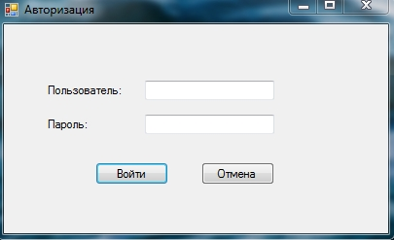

Рисунок Б.1 – Окно авторизации

Если данные для входа будет неверными, то, в результате, отобразится сообщение, которое можно увидеть на рисунке Б.2.

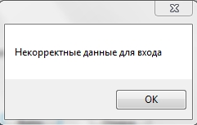

Рисунок Б.2 – Сообщение при неправильном вводе данных для авторизации

При вводе корректных данных отобразится форма, представленная на рисунке Б.3.

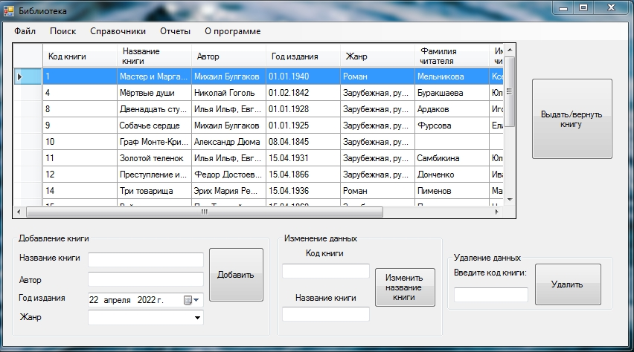

Рисунок Б.3 – Форма каталога книг

На данной форме отображен весь список книг, находящихся в фонде библиотеки. Можно добавить, изменить и удалить определенную книгу. Также, следует сказать, что эта форма является, в некотором смысле, основной. Большинство функций доступны из этой формы. Ниже будут подробно описаны эти функции.
Вверху формы каталога книг есть удобное меню, оно изображено на рисунке Б.4.

Рисунок Б.4 – Меню для работы с программой

Функция «Поиск» открывает окно поиска, которое изображено на рисунке Б.5.

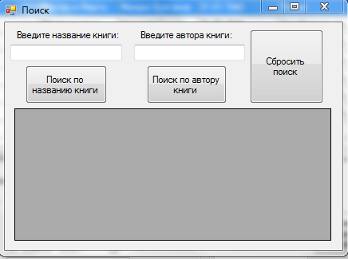

Рисунок Б.5 – Меню для работы с программой

Есть 2 критерия для поиска: поиск по названию книги, поиск по автору книги.
При закрытии формы отображается форма каталога книг.
Следующая функция, доступная из этой формы – открытие справочников. Форма справочников представлена на рисунке Б.6.

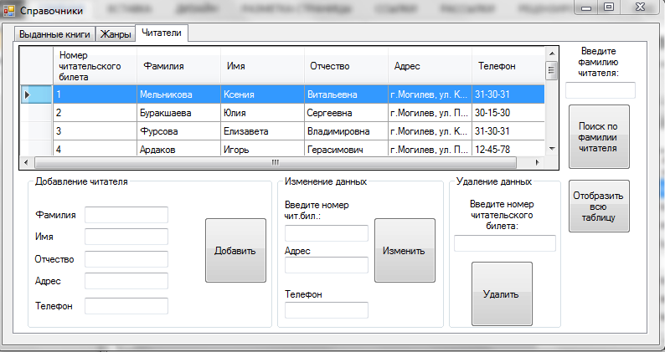

Рисунок Б.6 – Форма справочников

На данной форме размещен элемент TabControl (3 закладки). В программе 3 справочника: «Выданные книги», «Жанры», «Читатели». На вкладках «Жанры» и «Читатели» есть возможность добавления, изменения и удаления данных, а также разработан поиск по таблицам. На вкладке «Выданные книги» можно ознакомиться с информацией о выданных книгах и обновить набор данных в таблице. Заполнение этой таблицы происходит из другой формы.
Закончив работу со справочниками, снова возвращаемся на основную форму.
Еще одна доступная функция – это формирование отчетов. Ест возможность сгенерировать следующие отчеты: отчет по книгам, отчет по читателям, отчет по невозвращенным книгам. Вид сформированных отчетов представлен на рисунках Б.7-Б.9.

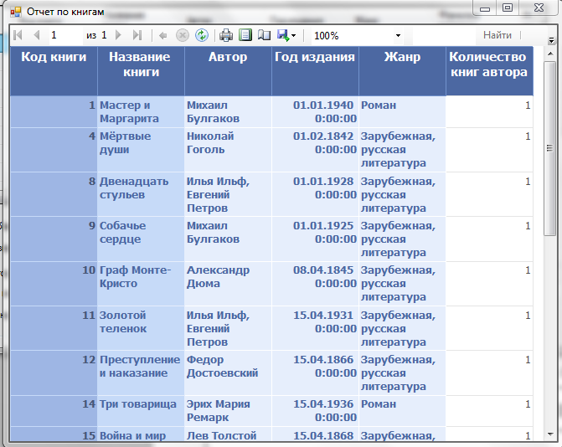

Рисунок Б.7 – Отчет по книгам

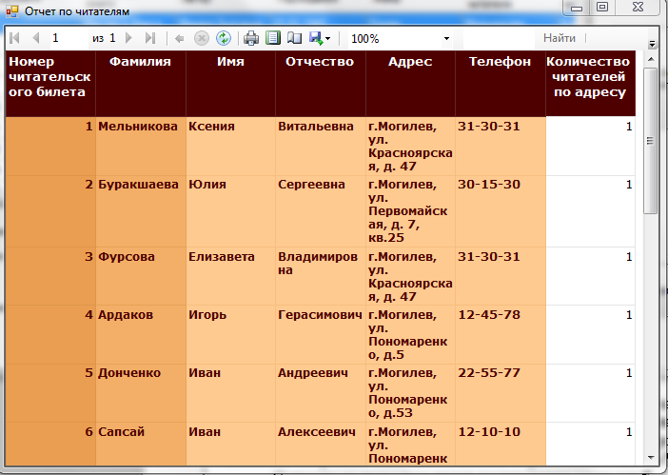

Рисунок Б.8 – Отчет по читателям

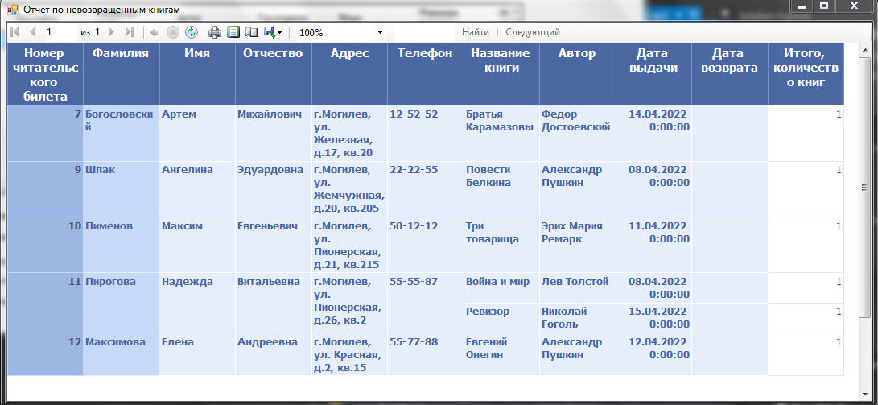

Рисунок Б.9 – Отчет по невозвращенным книгам

Помимо отчетов из главной формы еще доступна справка, представленная на рисунке Б.10.

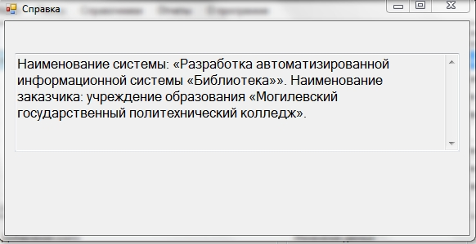

Рисунок Б.10 – Окно справки

Также можно из главной формы выдать/вернуть книгу. При этом открывается окно, представленное на рисунке Б.11.

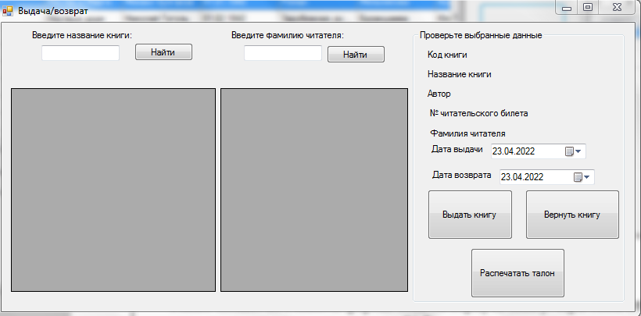

Рисунок Б.11 – Окно «Выдача/возврат»

После поиска и заполнения полей даты можно выдать книгу посетителю библиотеки либо вернуть ее назад в библиотеку. Также можно в это окне распечатать талон читателя, воспользовавшись поиском для выбора нужного читателя.
Талон читателя представлен на рисунке Б.12.

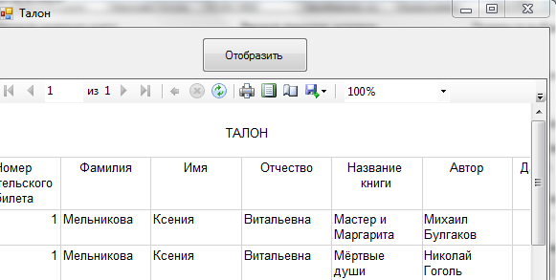

Рисунок Б.12 – Сформированный талон читателя

Выйти из программу можно через меню «Файл-Выход» либо нажав в правом верхнем углу на кнопку креста.

Приложение В
(обязательное)

Описание программы

1 Общие сведения

Наименование программы: Разработка автоматизированной информационной системы «Библиотека».
Автор программы: Борозна К.Г.
Дата создания: 01.05.2022.
Версия 1.0
Средой для функционирования программы являются операционные системы Windows.
Программа написана на языке программирования C# в интегрированной среде разработки Microsoft Visual Studio 2013.

2 Функциональное назначение

В рамках проекта разрабатывается автоматизированная информационная система «Библиотека».
Цели создания системы.
В результате создания системы должны быть улучшены показатели:
- замещение рукописного оформления талонов читателей;
- ведение рукописного учета книг, а также удобство работы с прочей многочисленной документацией;
- повышение оперативности выполняемой работы.

3 Описание логической структуры

В ходе работы над проектом была разработана автоматизированная информационная система «Библиотека».
Разработанная программа позволяет:
- оформлять талоны и другие отчеты;
- искать нужную информацию;
- редактировать содержимое базы данных;
- выводить на печать отчет.
Она предоставляет: удобный интерфейс, возможность избежание ошибок при оформлении отчетов, работу с базой данных, ее редактирование и вывод на печать для отчета, простоту применения.
Преимущества данной программы перед другими:
- бесплатный доступ;
- эргономичный и понятный дизайн;
- расширенный функционал.
4 Используемые технические средства

Для успешного запуска и выполнения программы необходимы следующие программные и аппаратные характеристики:
- операционная система Windows 7 (64 bit) и выше;
- оперативная память не менее 2 Гб;
- процессор с тактовой частотой 400 МГц;
- видеокарта и монитор SVGA с разрешением не менее 1024x768 точек;
- мышь;
- клавиатура;
- привод DVD-ROM;
- не менее 50 МБ свободного пространства на жестком диске.
Рекомендуемые программные и аппаратные характеристики:
- операционная система Windows 7;
- оперативная память 2 Гб;
- процессор с тактовой частотой 1000 МГц;
- видеокарта и монитор SVGA с разрешением не менее 1024x768 точек;
- мышь;
- клавиатура;
- привод DVD-ROM.
- не менее 50 МБ свободного пространства на жестком диске.
Для корректного завершения работы программы и операционной системы рекомендуется использование источника бесперебойного питания.

5 Вызов и загрузка

Дистрибутивный носитель данных поставляется на CD диске. Объем дистрибутива составляет около 29,9 Мб, пользователь осуществляет следующие действия:
- загрузка любого файлового менеджера;
- переход на DVD-ROM;
- запуск с ярлыка с типом «Приложение».

